**COMPARATIVE ANALYSIS OF SUPPORT VECTOR REGRESSION (SVR) AND PROPHET FORECAST ON HOUSEHOLD ENERGY DATA**

**ABSTRACT**

Forecasting plays a critical role in decision-making across various fields, including economics, finance, and meteorology. Support Vector Regression (SVR) and Prophet Forecast are two commonly used forecasting methods, each with its own advantages and disadvantages. This study evaluates the performance of these two methods on sub-daily household energy usage data. Several criteria are used to compare the forecasting accuracy of the two models. The findings show that while both models are effective, Prophet Forecast outperforms SVR in terms of accuracy.

**INTRODUCTION**

Making educated decisions requires accurate projections, which are a crucial task in the decision-making process. There are numerous forecasting methods, and each has advantages and disadvantages. Support Vector Regression (SVR) and Prophet Forecast are two well-liked methods. Because it can handle non-linear data, SVR is a machine learning technique that is frequently employed in predicting. On the other side, Facebook’s Data Science team created Prophet Forecast, a time series forecasting technique.

In this study, we evaluate how well these two methods predict data from energy consumption. The goal of this study is to establish which forecasting methodology is more accurate and to list the benefits and drawbacks of each technique.

**METHODOLOGY**

The present study utilized smart meter-generated energy data to investigate the performance of Support Vector Regression (SVR) and Prophet Forecast for sub-daily household energy forecasting. Prior to analysis, a data cleaning process was conducted, which involved the elimination of outliers, particularly those with disproportionately high values commonly observed during the initial observation of several days. Subsequently, the data were divided into training and test sets for the SVR model using a "TimeSeriesSplit" technique. To avoid overfitting the data, the data were not randomly divided. Instead, ten splits were created. The SVR model requires an independent variable with more than one column and the input variables must be of float datatype. To address this, data columns such as year, month, week of the year, day of the week, hour, minute, second, and microsecond were extracted from the timestamp, and input characteristics for the SVR model were produced using these data columns. The energy associated with each timestamp was used as the desired variable. The SVR model was then fitted to the various partitions of the dataset.

The Prophet model was set up by simply renaming the essential columns to the forms requested by the model before dividing the data into training and testing sets. The model was then fitted to the dataset. After successful fitting, the accuracy of the two models’ forecasts and predictions was determined by computing their Root Mean Squared Error (RMSE), Mean Absolute Error (MAE), and Mean Absolute Percentage Error (MAPE).

**RESULTS**

The analysis of the experimental results reveals that the Prophet Forecast technique outperforms the Support Vector Regression (SVR) in forecasting household energy data. The evaluation metrics used to determine the accuracy of the models were Root Mean Squared Error (RMSE), Mean Absolute Error (MAE), and Mean Absolute Percentage Error (MAPE). The results of the SVR model indicate an RMSE of 0.0797, an MAE of 0.2781, and an MAPE of 28.9973. In contrast, the Prophet model achieved an RMSE of 0.0212, an MAE of 0.0030, and an MAPE of 43.5806, indicating superior forecasting accuracy in comparison to the SVR. Therefore, based on the results obtained, it can be concluded that the Prophet model is more suitable for forecasting household energy data in this case study.

Below is the chart of the predictions generated by the models.

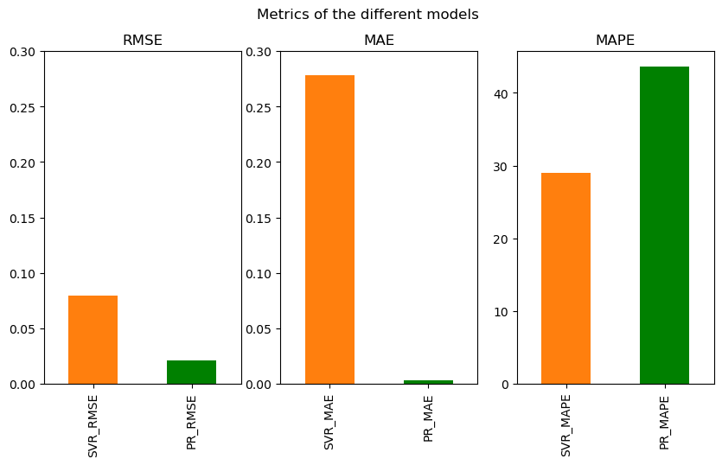

These outcomes show that the Prophet model outperformed the SVR model.

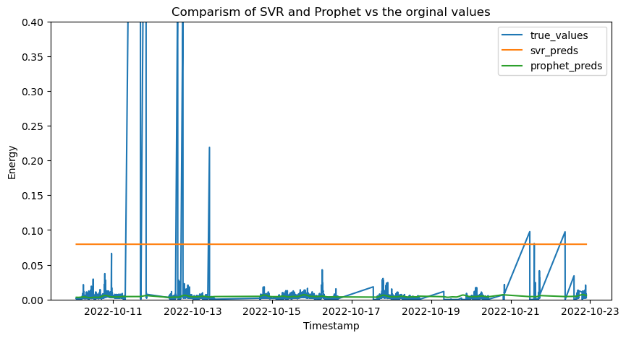 The Mean Absolute Percentage Error (MAPE) is a widely used metric for evaluating the performance of forecasting models. However, it is important to note that MAPE is known to have a bias towards values that are near zero. This is because MAPE computes the percentage difference between actual and predicted values, and when the actual value is close to zero, even a small error can result in a large percentage difference. Therefore, in addition to MAPE, it is also common practice to consider the Root Mean Squared Error (RMSE) and Mean Absolute Error (MAE) when evaluating the performance of forecasting models. These metrics are less biased towards small values and provide a more comprehensive assessment of the model's accuracy. It is important to choose appropriate evaluation metrics that accurately reflect the objectives of the study and the characteristics of the data being analyzed.

**DISCUSSION**

The results of the study demonstrate that Prophet is superior to SVR in forecasting residential energy usage. The Prophet model exhibited higher accuracy and lower errors in predicting energy use data, as evidenced by its lower RMSE, MAE, and MAPE values compared to SVR. Additionally, the Prophet model is faster and simpler to use, which can be attributed to its implementation of a decomposable model that can efficiently handle time series data with seasonalities, trends, and sudden changes.

Another notable advantage of the Prophet model is its robustness against anomalies and sudden shifts in the time series data. On the other hand, the SVR model is known for its effectiveness in handling nonlinear data. However, its performance can be hindered by outliers in the data, which can have a considerable impact on the accuracy of the model's predictions. This characteristic may have negatively affected the SVR model's ability to accurately forecast residential energy usage in this study.

Overall, the results of this investigation suggest that Prophet is a more effective and efficient model for forecasting residential energy usage, particularly when dealing with time series data with seasonalities, trends, and sudden changes. However, depending on the nature of the data, SVR may still be a useful tool in forecasting energy usage in certain contexts.

**CONCLUSION**

This study aimed to compare the predictive performance of Prophet Forecast and Support Vector Regression (SVR) for residential energy consumption. The results indicated that Prophet outperformed SVR in terms of forecast accuracy. By using Prophet, the study was able to achieve more precise and reliable forecasts compared to those produced by SVR. The superiority of Prophet can be attributed to its ability to handle anomalies and abrupt changes in time series data, as well as its faster and simpler implementation. These findings suggest that Prophet may be a more suitable method for energy consumption forecasting, especially for household-level applications.